
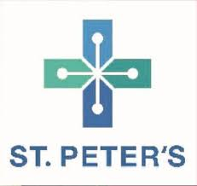
PHARMA FOCUS
News Letter

St. Peter’s College of Pharmacy and Research Institute
Dr. M.G.R Nagar, Hosur-635130

Contact: 9741156204 E-mail:pharmacycollege@spmch.ac.in

Volume 1, Issue 1, December 2023 – December 2025
About college:
St. Peter’s Pharmacy College and Research Institute, Hosur is the constituent unit of St.Peter’s Institute of Higher Education and Research, Chennai and Affiliated to the Tamil Nadu Dr. M G R Medical University Chennai and Approved by Government of Tamil Nadu and Pharmacy council of India, New Delhi.
St. Peter’s Pharmacy College and Research Institute being established from the academic year 2023- 2024 in the Dr. M G R Nagar, Hosur. We are running D.Pharm and B.Pharm Courses in spacious well equipped building of its own with hostel, library and sports facilities.

Pharmacy is a noble profession dedicated to the Development of Drugs that heal and comfort the sick. The pharmacist is an important member of the health care profession who has the educational background and experience to serve as therapeutic consultant. Realizing the necessity of Quality pharmacy education in the area.
Celebration of 62nd National Pharmacy Week
The 62nd National Pharmacy week held at St. Peter’s Pharmacy College and Research Institute, Hosur on 8th December 2023 with a Inauguration Program conducted in the college auditorium with Chief Guest Dr. D S VASUDEVA, Medical superintendent, Dr. R M RAJAMUTHIAH, Medical Director, Dr. PARVATHI, Trustee, Dr. D C PREM ANAND, Principal St. Peter Pharmacy College and Research Institute. The program blend of cultural reverence and academic excellence, reflecting the vital role pharmacist in health care The Theme of 62nd National Pharmacy week is “Join the Pharmacist to Ensure Patient Safety”.
Chief guest addressed the gathering speech, he emphasized the critical role of pharmacists in the healthcare system, underscoring their importance in patient care and community heath. Students from various pharmacy courses including B Pharm and D Pharm were in attendance, reflecting the diverse academic community of the college.
The ceremony recognizes the contributions of pharmacists, inspiring students and reinforcing the commitment to excellence in pharmaceutical education and practice.
Awareness program on “Legal Literacy Awareness programme and drugs awareness”
Awareness programme was conducted on legal literacy awareness programme and drug awareness by the Para Legal volunteer Thiru. R. Govindaraj sir on 22.02.2024 in St. Peter’s Pharmacy College and Research Institute. He shared valuable information about Drug and Cosmetic Act.1948, Sexual harassment in public transport and Anti-ragging. Also he spoke about legal committee members present in every taluk to take legal action against them.
Finally the session was very use full for our students and faculties also.
St. Peter’s Pharmacy College and Research Institute Celebrated International Women’s Day on 8th March 2024.
The programme was conducted in presence of chief guest Dr. Anupama, Professor and Head of the Department of Anatomy, SPMCH, Hosur
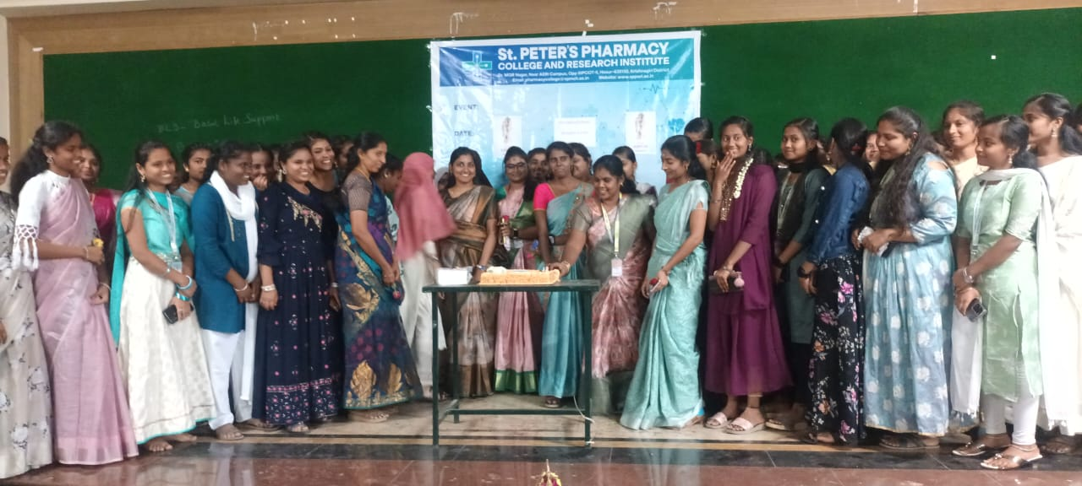
Theme is “Invest in women: Accelerate Progress”
The theme focused on inspiring and empowering women across all sectors of society.
All the faculties and students were present in the programme and our chief guest shared inspiring information about empowering the women across all the sectors of society. And the programme was concluded with vote of thanks.

Green Club
Green club was established with the objectives of
- To conserve the natural sources, the natural resources and the natural environment.
- To create eco-friendly environment
- To create awareness on biodiversity conservation
- To create clean and green consciousness among students through various innovative methods
Activities of green club in college:
St. Peter’s Pharmacy College and Research Institute celebrated 53rd “World Forest Day” on march 21. The motive of this celebration is to make our environment pollution free and to encourage to conserve forests. This function was organized by our faculty and students who are the members in Green club and NCC.
The Theme is “FORESTS AND INNOVATION (NEW SOLUTION FOR BETTER WORLD)”
In this function we were planted various medicinal plants in our medical garden near pharmacy campus.
Name of the plant | Medicinal uses
Thiruneetrupachillai | To treat kidney malfunctions
Thipili | To treat Indigestion
Nagathali | To treat problem with Nervous system
Nandhiyavattam | To treat skin diseases
Karunochi | To treat intestinal worms
Murungai | Protecting liver from damage
Agathi | To treat Migraine
Thoothuvallai | To treat Thyroid problem
Hibiscus | To treat Heart and Nerve Disease
Papaya | To treat Low BP and Diabetes

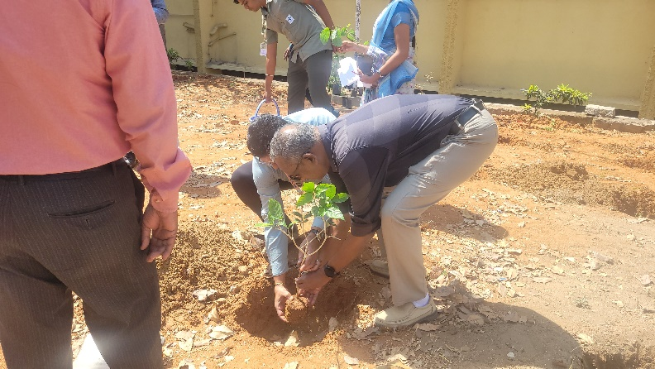
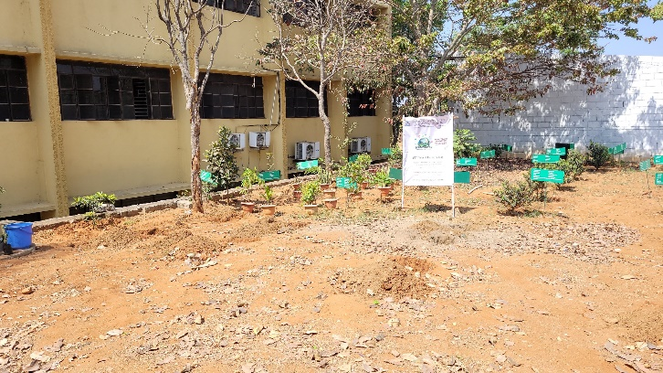
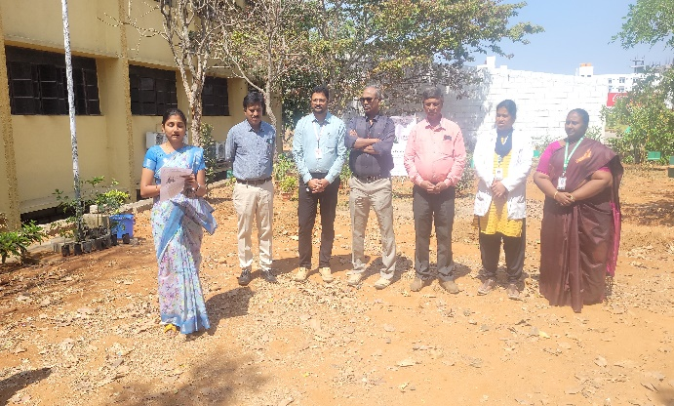

RED RIBBON CLUB
Awareness program was conducted on HIV/AIDS as a part of “RED RIBBON CLUB” activity
Theme is “CELEBRATING LIFE”
Mr. SAM JEBASTIN, Art counsellor at St. Peter’s Medical College Hospital and Research Institute, Hosur was the speaker for the session. He shared information regarding HIV/AIDS, its signs and symptoms, causes, preventive measures, treatment and also gave us the information on what is the main role of ART CENTERS AND ICTC.

International Day of Yoga
St. Peter’s Pharmacy College and Research Institute celebrated INTERNATIONAL DAY OF YOGA on 21-06-2024 by conducting an active yoga session by Mr. P BABU, Yoga trainer , Hosur. He also give guest lecture on the benefits of practicing yoga on our daily life style.
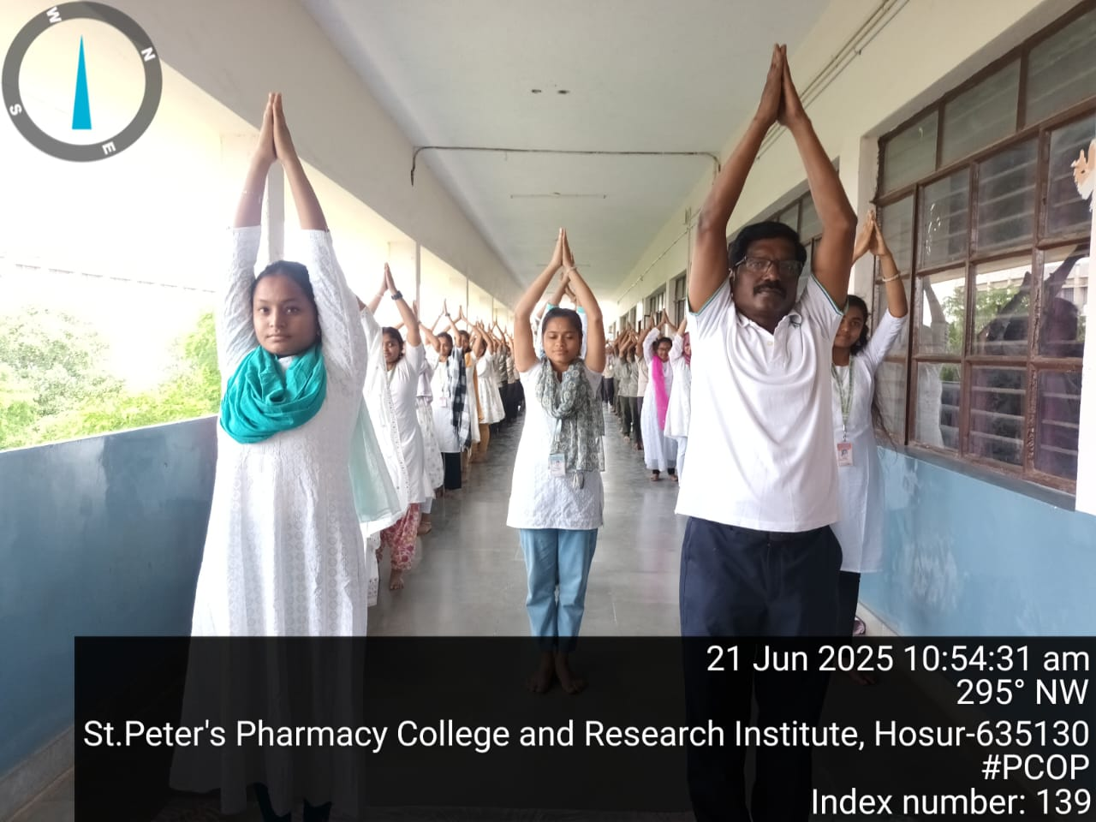

Awareness Programme on International Day Against Drug Abuse and Illicit Trafficking
On behalf of INTERNATIONAL DAY AGAINST DRUG ABUSE AND ILLICIT TRAFFICKING an awareness programme was conducted on 26-06-2024 by the Department of Pharmacy Practice. The chief guest cum speaker Dr. INIGA MARIA DIVYA B, MD Department of Psychiatry, SPMC&RI gave us a seminar on “SUBSTANCE USE DISORDER”, also gave the information regarding the complications, withdrawal symptoms and also non pharmacological treatment for the drug abuse.
78th Independence day celebration
St. Peter’s Pharmacy College and Research Institute celebrated 78th Independence day on 15th August 2024. National flag hoisted by Dr. Sarika Naik Professor and HOD Anesthesiology at 8.30 AM in our campus. Dr. R. M. Rajamuthaiah, Medical Director, Dr. Parvathi, Trustee. Dr. D. C Prem Anand, Principal of St. Peter’s Pharmacy College and Research Institute were present.

Motivational Program On Stress Management
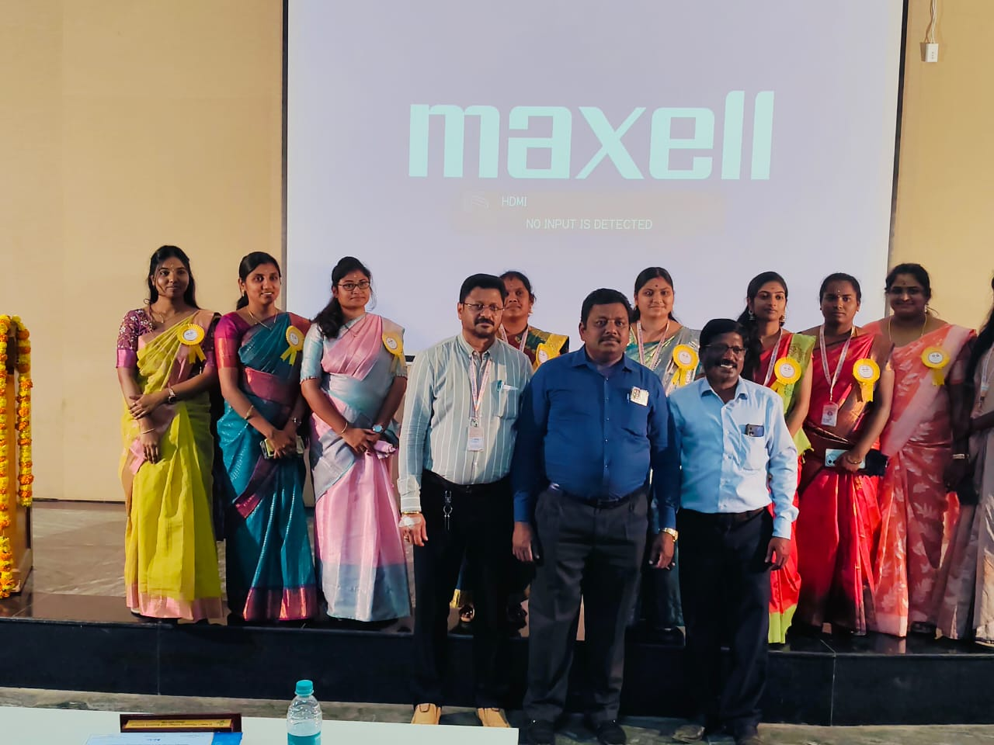
A motivational program on stress management was conducted at St. Peter’s Pharmacy College and Research Institute on 30-08-2024. The Resource person was Dr. G. Murugananthan, Principal of Swami Vivekanandha College of Pharmacy, Thiruchengode was presented a motivational speech for our students. The topic delivered by him was about stress management and also he taught them breathing exercise for the stress management. The programme was truly worthy and motivative.
One Day National Seminar on “PHARMACEUTICAL SCIENCES AND INNOVATIONS IN PHARMA INDUSTRY”
St Peter’s Pharmacy College and Research Institute conducted one day seminar on Pharmaceutical Sciences and Innovations in Pharma Industry in three sessions.
Session- I was started by the speaker Dr S Kavimani, professor and HOD of pharmacology, Mother Theresa Post Graduate and Research Institute of Health sciences, Pondicherry, on the topic “Repurposing Strategy; A Tool for drug discovery”. It was really an interesting session and also interactive, sir gave us the detailed knowledge about drug discovery.
Session-II was started by the speaker Dr. M. Gandhimathi, Professor, Department of Pharmaceutical Analysis, Shri Ramakrishna College of Pharmacy, Coimbatore, on the topic “Tactics in Bio analytical Method development and Validation.” The session was very informative.
Session- III was started by our eminent speaker Dr. K. Anandakumar, Professor and principal, Vivekanandha Pharmacy College for women, sankagiri on topic “Artificial Intelligence In Pharma Industry”. Sir gave us the detailed note on artificial intelligence which can be applied in Pharma Industry. The session was truly inspired.
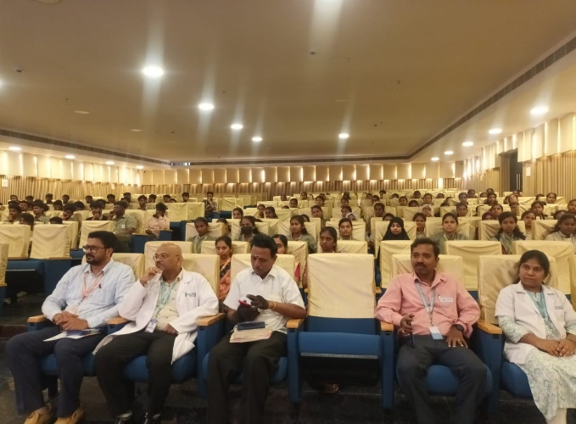
Nearly 550 students from various colleges were actively participated in the seminar.
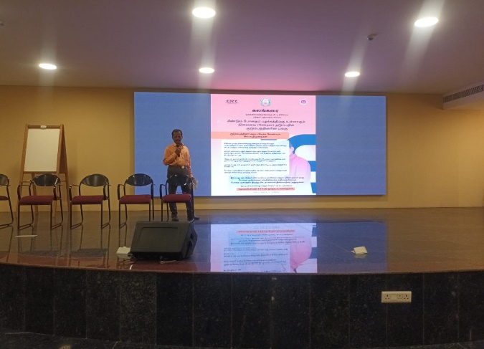

Pharmacist Day- 2024
St Peter’s Pharmacy college celebrated World Pharmacist day on 25th September with the theme “Pharmacists Meeting Global Health Needs” by inviting the chief guest Dr. D Rajiv Gandhi, M Pharm, MBA, who is working as Drug Inspector. He gave us the brief talk on the actual role of pharmacist in various fields such as hospital, clinical research, quality control and quality assurance, patient counselling and also on drug abuse in youth.

Celebration of 63rd National Pharmacy Week
We celebrated 63rd National Pharmacy Week with the “Think Health, Think Pharmacy”. The celebration started with the sports session which includes Outdoor games and Indoor games. Students were actively participated in cricket volley ball, kabaddi, throwball, tennikoit and indoor games like carrom, chess. Prizes for all the games were declared by the referees.
Scientific session was also conducted which includes elocution, essay writing, drawing and rangoli with the theme. This session made us to know about many new innovative idea and current trends in pharma field.
Cultural session was conducted which includes solo dance, group dance, solo singing, group singing, fireless cooking, fruits and vegetable carving, skit, mime and short film with pharma theme and message. Students were actively participated in all the activities and made the celebration memorable.

National Science Day- 2025
St. Peter’s Pharmacy College and Research Institute Celebrated National Science Day on 28-02-2025 with the theme “Empowering Indian Youth for Global Leadership in Science and Innovation for Viksit Bharat”, emphasizing the crucial role of young Minds in shaping India’s future through science and innovation.
The event commenced with a formal opening meeting, where a brief yet engaging introduction to National Science Day was presented. The significance of the day, its historical relevance and the theme of year 2025 were thoughtfully addressed.
An interactive session was a highlight of the celebration. As a part of the event, an essay writing competition was conducted. The winner of the competition was acknowledged and awarded.

Industrial Visit : Maiva Pharma Pvt Ltd
As a part of curriculum and students interest, our B pharm and D pharm students visited Pharmaceutical industry, Maiva Pharma Pvt Ltd. The visit was fruitful for the students they gained knowledge about development and manufacturing of sterile liquid and Iyophilized injectables, stability studies and also about analytical testing. The visit was very helpful for the student carrier growth.
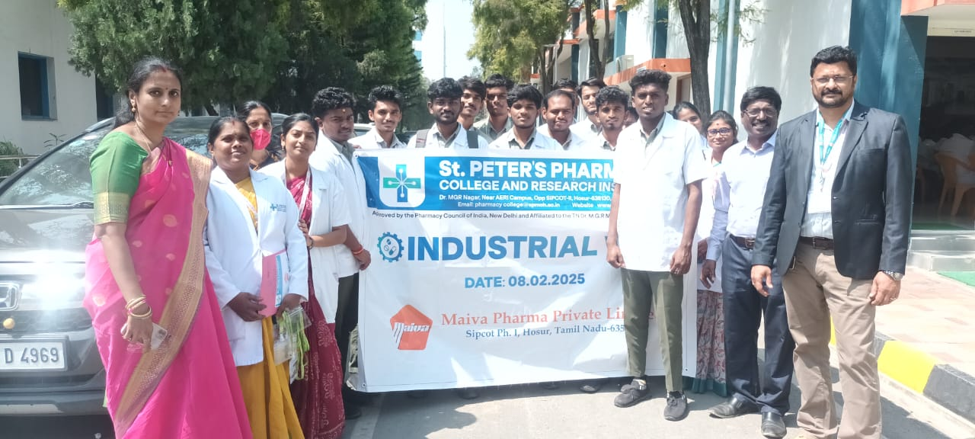

Observational students visit to Siddha Medicinal Plants Garden
St Peter’s Pharmacy College and Research Institute, as a part of our Pharmacy curriculum, students and faculties visited Siddha Medicinal Plants Garden at Mettur Dam to acquire practical knowledge for medicinal plants on 25-07-2025.
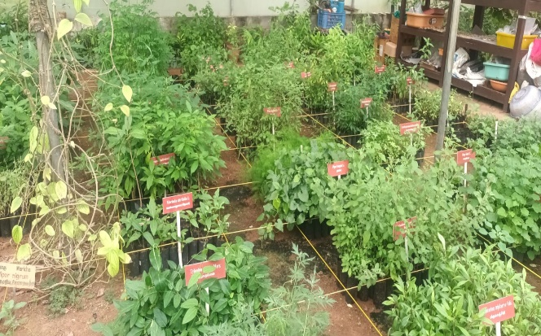
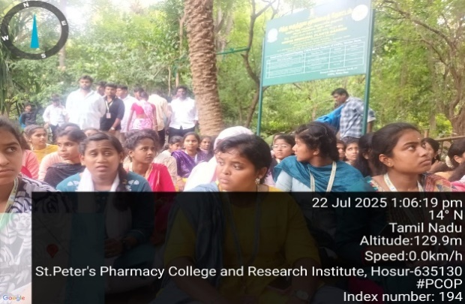
The visit was very informative and gained the knowledge about medicinal plants, their active constituents and medicinal uses.
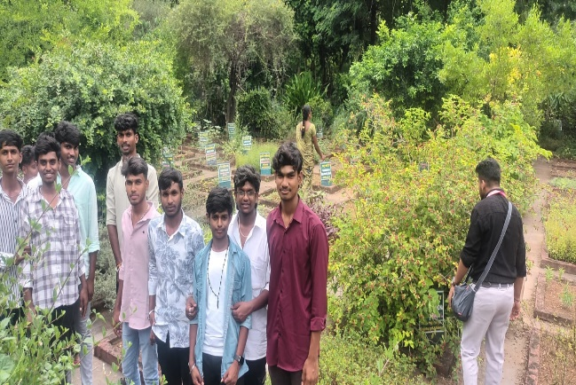
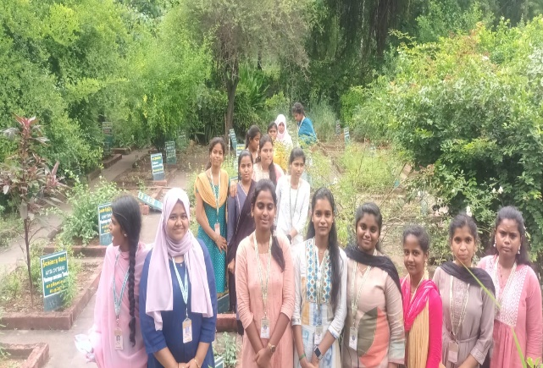

Industrial Visit :Aavin Milk Dairy
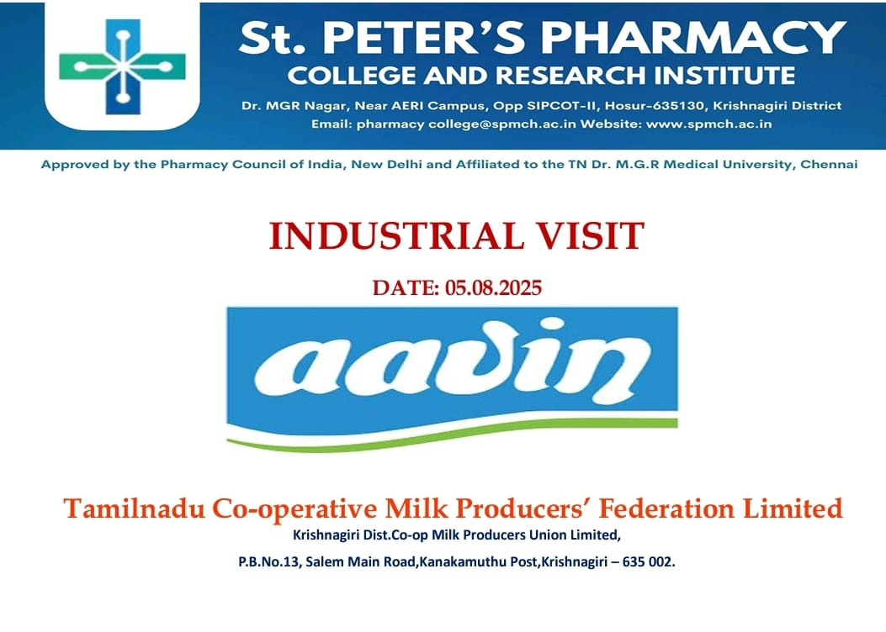
As per B Pharm and D Pharm curriculum Our students visited Aavin Milk Dairy at Krishnagiri on 05-08-2025. Students gained the knowledge about milk processing, manufacturing of various dairy products, quality testing and marketing and distribution. The visit was so informative and beneficial to our students.
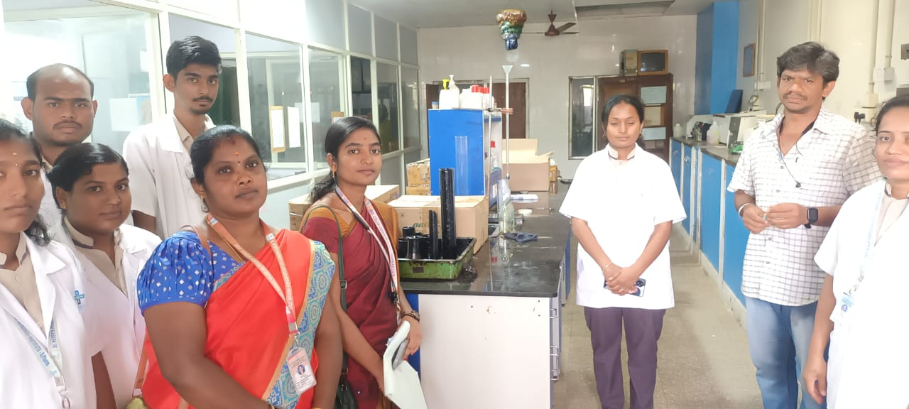
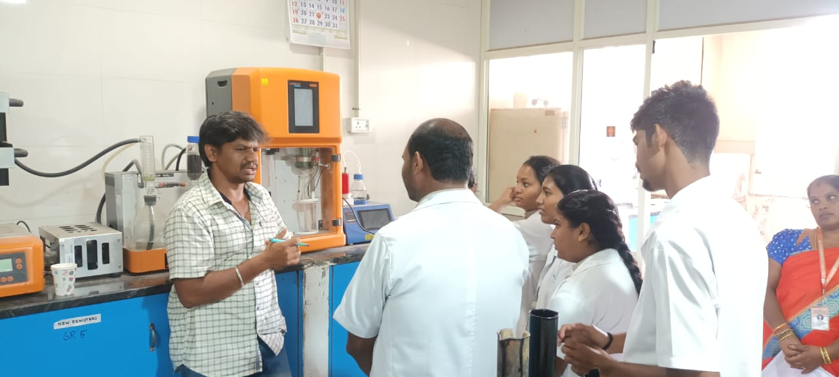

National Level Seminar on AI Impact On Drug Discovery and Development
St Peter’s Pharmacy College and Research Institute conducted one day national level seminar on 21-08-2025 on topic “AI Impact on Drug Discovery and Development”.
The speakers are
- Dr. S Kavimani, Professor and HOD of Pharmacology, Mother Teresa Post graduate and Research Institute of Health sciences, Pondicherry.
- Dr. M Ganthi Mathi, Professor and HOD Pharmaceutical Analysis, Sri Rama Krishna College of Pharmacy, Coimbatore.
- Dr. Ananda Reddy, Vice Principal, St. Peter’s Medical College and Research Institute Hosur.
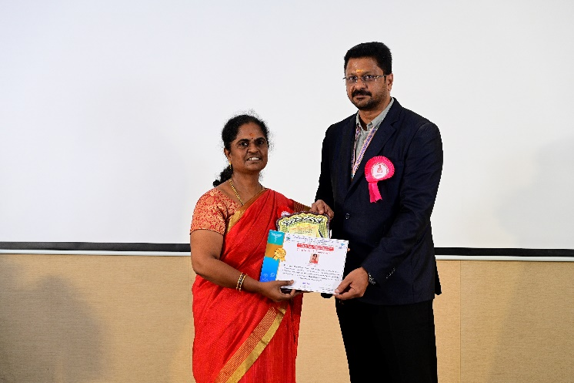
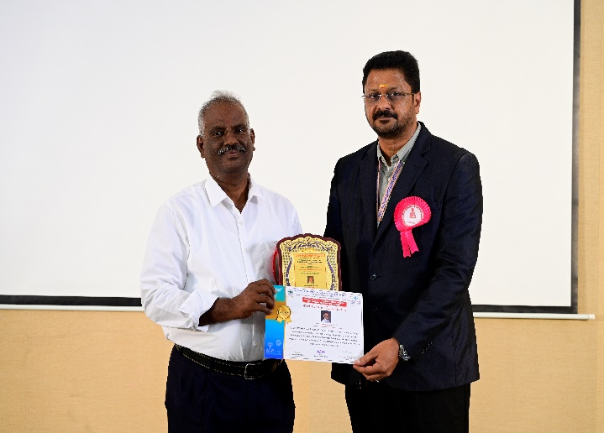
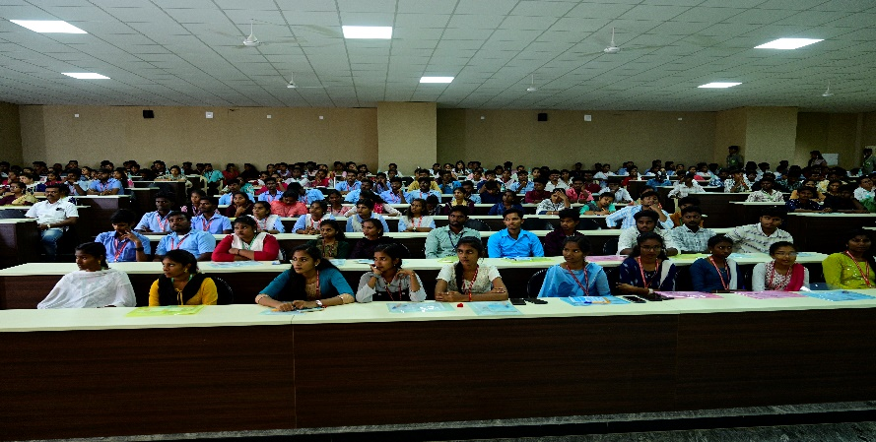
All the speakers shared a valuable information about AI impact on drug discovery, Merits and Demerits of AI. The session was very beneficial to all students. Students from various colleges actively participated and made the session successful .
Celebration of 64th National Pharmacy Week
We celebrated 64th National Pharmacy Week from 15-12-2025 to 22-12-2025 with the theme “Pharmacists as a Advocates of Vaccination”. The celebration started with the Inaugural function by our chief guest Dr. R M Rajamuthiah sir and then proceeded with march fast by our students and continued with sports session which includes Outdoor games and Indoor games. All Students were actively participated in cricket volley ball, kabaddi, throwball, tennikoit and indoor games like carrom, chess. Prizes for all the games were declared by the referees.
Scientific session was also conducted which includes elocution, essay writing, drawing and rangoli with the theme. This session made us to know about many new innovative idea and current trends in pharma field.
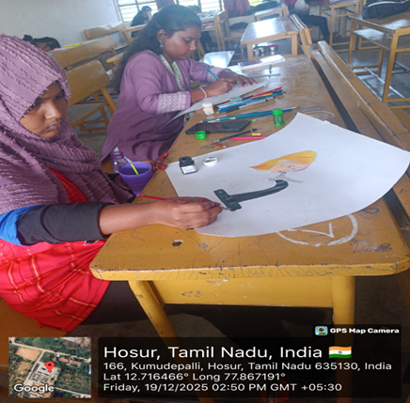
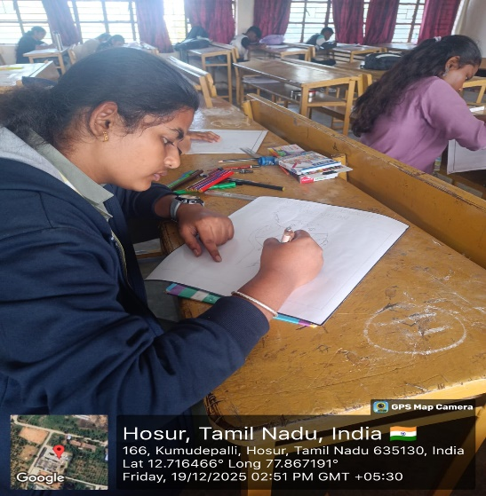
Cultural session was conducted which includes solo dance, group dance, solo singing, group singing, scientific session, fireless cooking, fruits and vegetable carving, skit, mime and short film with pharma theme and message. The programme was held about one week . Students were actively participated in all the activities and made the celebration memorable.

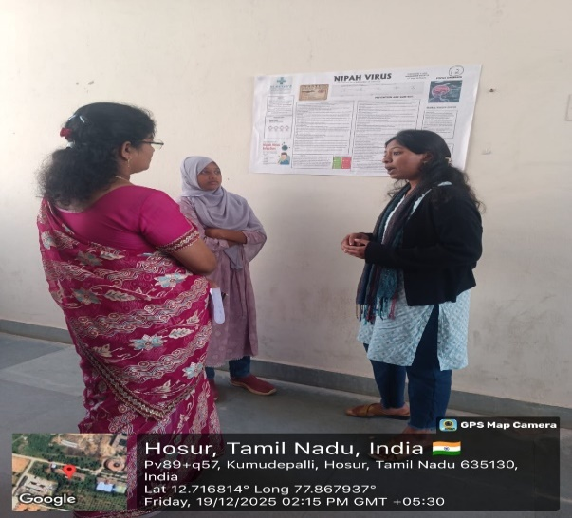
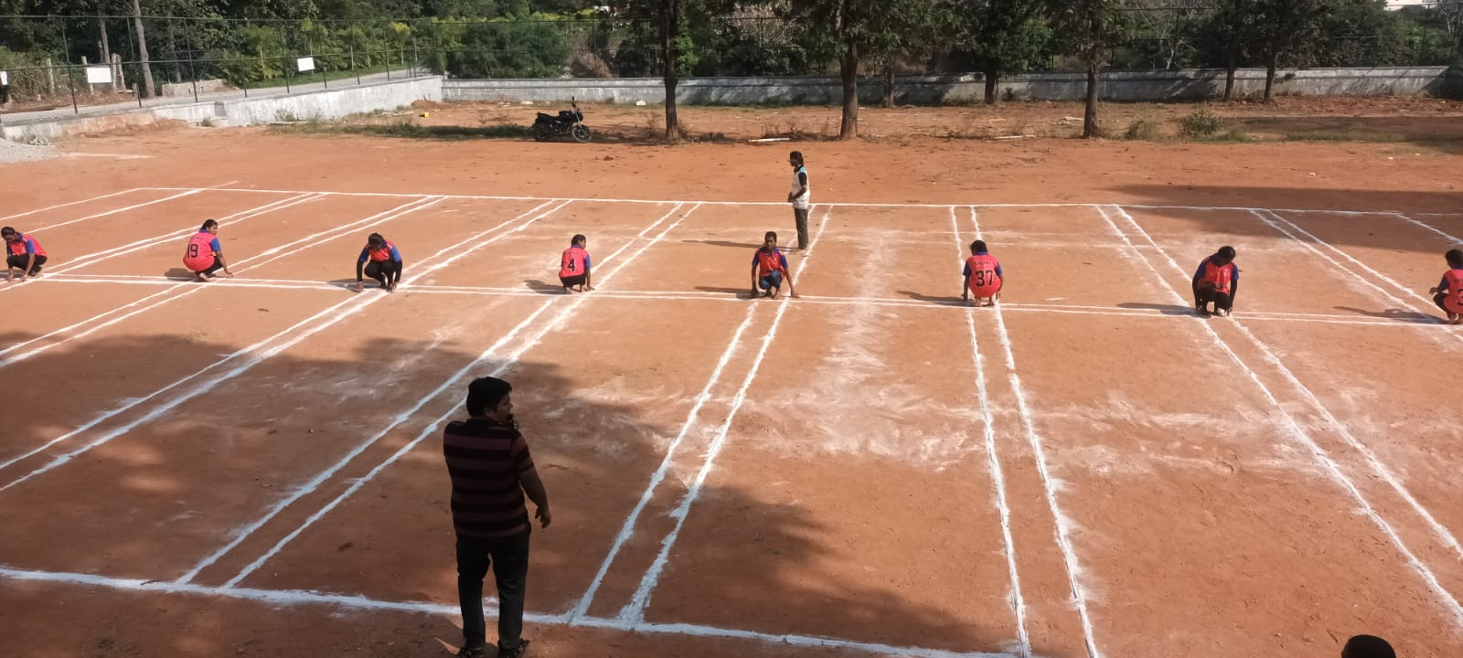
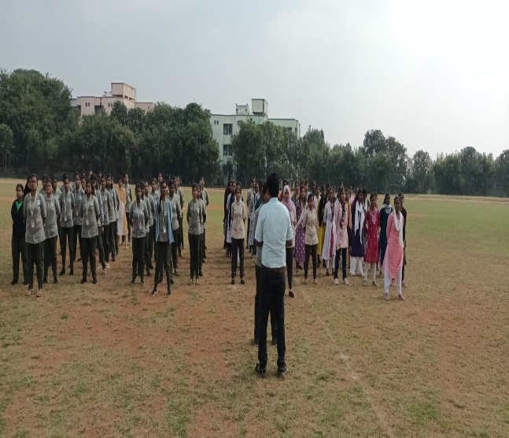
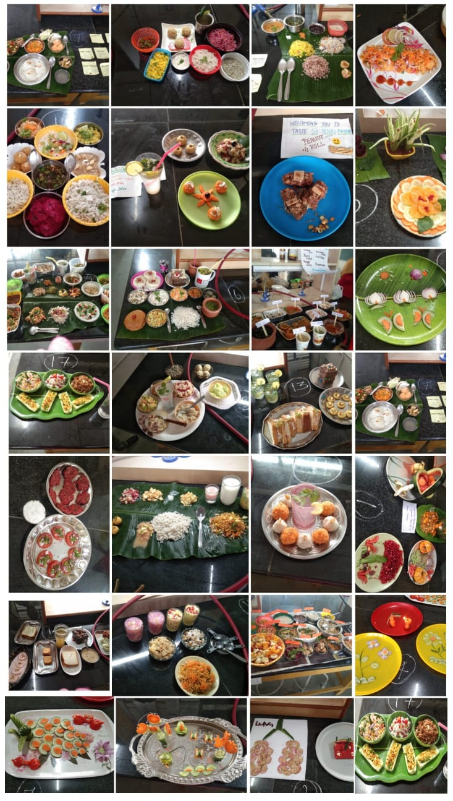
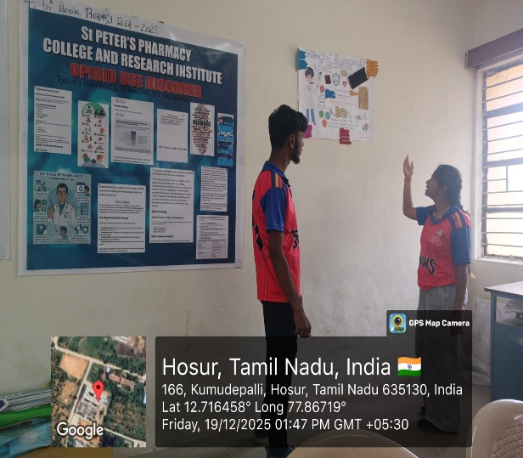
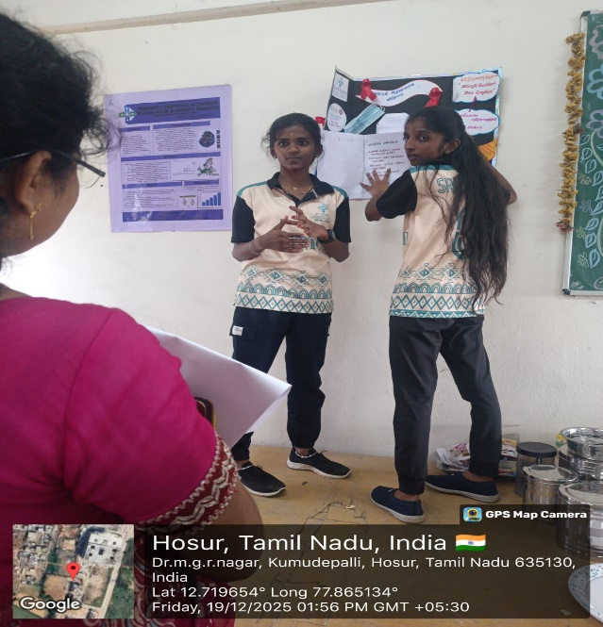

Students Rally on the event of National Pharmacy Week
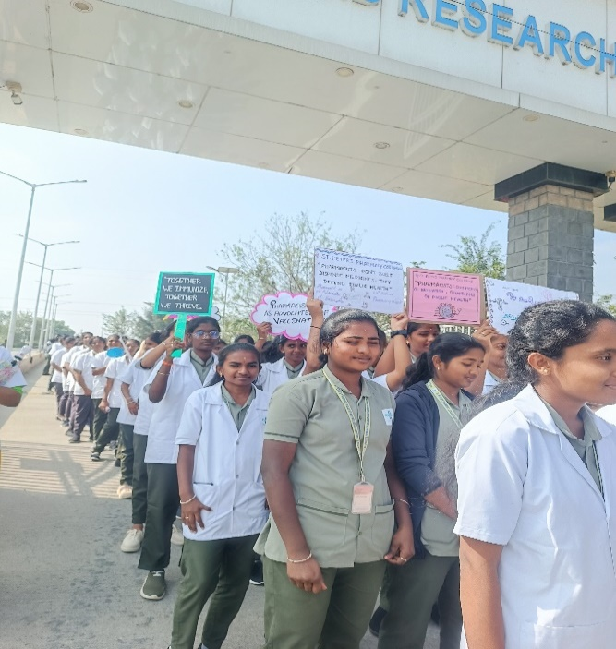
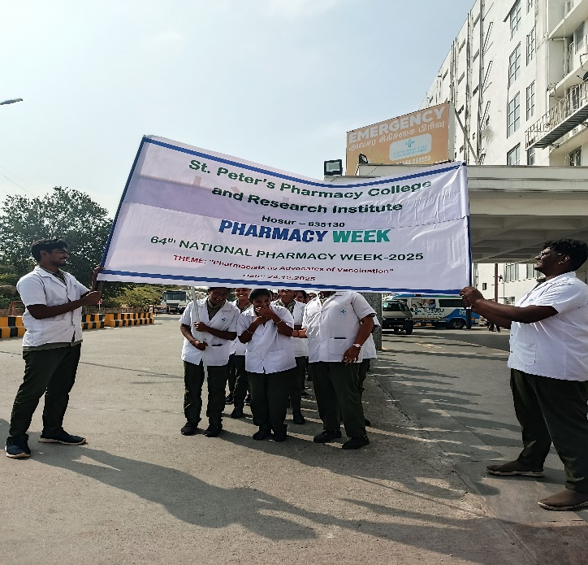
On the event of 64th National Pharmacy week Celebration, we conducted students rally on 23-12-2025 from St Peter’s Medical College Hospital and Research Institute to Bathalapalli bus stop. The purpose of the this rally was to educate public about role of pharmacists in vaccination. All the students and faculties were actively participated and made the rally successful.

Academic Achievers
B. Pharm
2023-2024 Batch
I  Semester | V.Vimala  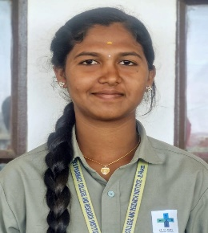  SCGPA:9.55 | M. Sneha  SCGPA: 9.26  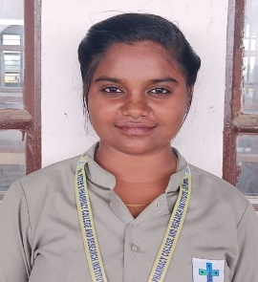 | R. Shoba  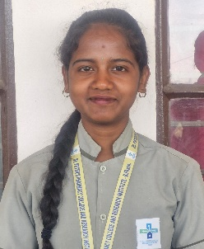  SCGPA:9.24 | - Suchitha  SCGPA: 9.10  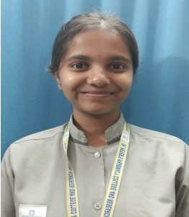
II Semester | H.Spoorthi  SCGPA:9.31  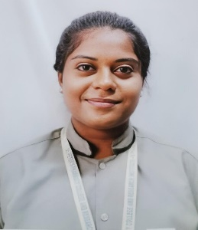 | M. Sneha  SCGPA:9.31 | V. Vimala  SCGPA:9.03 | S.V Gunapriya  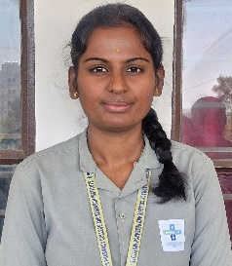  SCGPA:9.03 | R. Shrisha  SCGPA:8.96  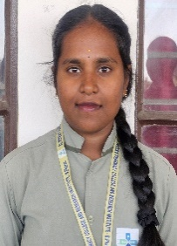
III  Semester | V. Janani  SCGPA:9.0  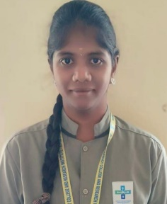 | M. Sneha  SCGPA:8.91 | H.Spoorthi  SCGPA:8.91  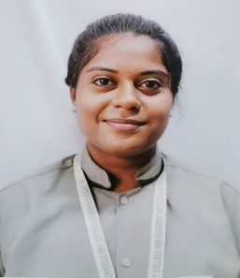 | S. V. Gunapriya  SCGPA:8.91 | V. Vimala  SCGPA:8.83
IV  Semester | M. Sneha  CGPA: 9.14 | H. Spoorthi  CGPA: 8.57 | D Jagadish  CGPA: 8.50  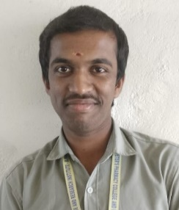

2024-2025 Batch
I Semester | Karnika M S  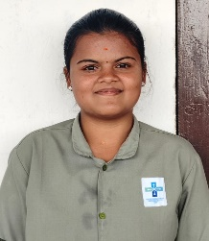  SCGPA: 9.18 | Gnanasegari T  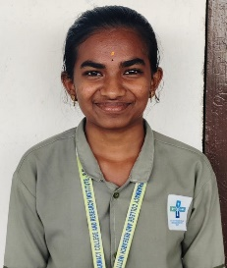  SCGPA: 8.96 | Varsha M  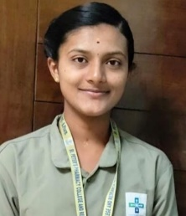  SCGPA: 8.89 | Puja Mandai  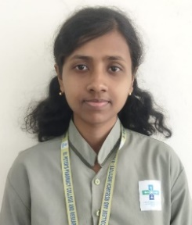  SCGPA: 8.89
II Semester | Gnanasegari T  SCGPA: 9.17 | Karnika M S  SCGPA: 8.96 | Puja Mandai  SCGPA: 8.96  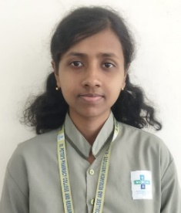 | Varnasri R  SCGPA: 8.86  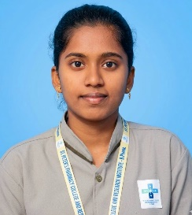

D Pharm
2023-2024 Batch
Chitra  Total Percentage : 78.81 %  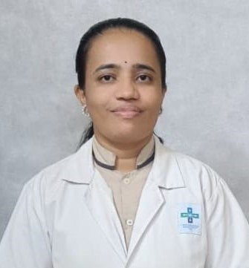 | Pooja  Total Percentage : 77.37%  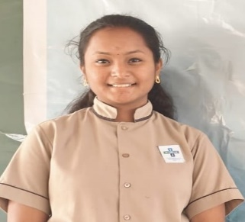 | Shyla  Total Percentage : 77.27%  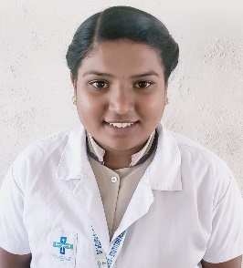

2024-2025 Batch
Saherabanu  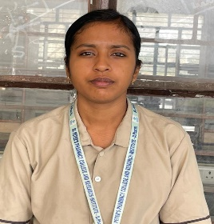  Total Percentage : 83% | Deepika R  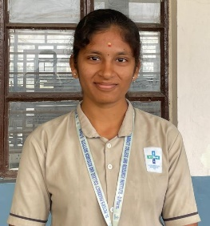  Total Percentage : 79% | Dhivya P  Total Percentage : 75%  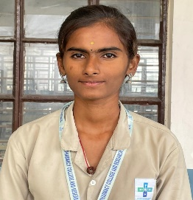

Patron cum Editor in Chief
Dr. D C Prem Anand, Dean, St. Peter’s Pharmacy College and Research Institute

Editors
Mrs. Shubha D B
Ms. V. Angelin Esther

Editorial Advisor
Dr. D C Prem Anand, Dean, St. Peter’s Pharmacy College and Research Institute

Editorial Members
Dr. Saraswathi
Mr. Ramesh Babu
Mrs. Usha
Ms. Shineka
Mrs. Mohana
Mrs. Priyanka
Mrs. Pradeepa
Ms. Gunavathi
Mr. Manikandan
Mr. Murasolimaran
Mr. Shreenidhibaran

